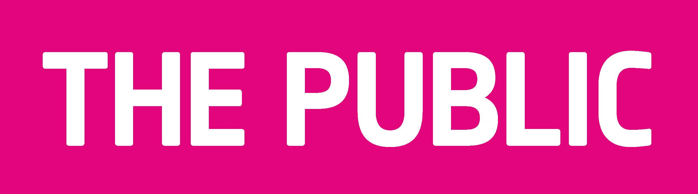

BRIEF – Bunting Instillation.
Project Title: Bunting for The Public.
Programme – July 2010 - 3 month period.

Project Curator: Beth White
Project start and finish date(s)
Tuesday 18th May – Tuesday 6th July 2010
Deadline – 6th July.
Details –
All pieces of work must be produced to the same size and shape specifications. Details are below.
Weight will be an issue, as all pieces will be attached together using bunting tape. Please take this into consideration when designing and producing your piece. If power is needed please specify this.
All the bunting must be able to be fire proofed or provided fireproofed.
When your piece of artwork is completed we would like you to add a short statement about your key ideas and inspirations. A separate form is included for you to complete, please make sure you add your name and also the number of pieced of work you will be submitting.

We may use your image as part of the promotion of the instillation through products that we produce to coincide with the exhibition. Please submit clear images of your piece or pieces of bunting taken on a clean white background.

The Brief –

To create an artistic bunting instillation within the newly opened Public gallery in West Bromwich.

Traditionally bunting is used as a form of decoration for street festivals and celebrations. The finished piece of work will be displayed in the café area of the gallery and will help to enliven this space.

Unlike traditional bunting, which is predominantly fabric based, the artist will be able to choose the material that they use, from paper to glass and from light to textiles. The fundamental difference of this project is to use traditional bunting, but rather than a repetitive format, each segment of bunting is an individual work of art.

This is a great opportunity to use the traditional frame of bunting to create a cutting edge work of art. We would like you to be extremely experimental with the mediums that you use.

Each artist is not limited to the amount of pieces that they can submit. But there will be a maximum of 150-200 pieces on display. All copyright is protected to the individual artist.

The work submitted will be the property of the Public. The work will be displayed for a three-month period and then used as and when appropriate. Other artists that the Public work with will be invited to develop their creations into bunting to keep the project live and each year the bunting will be displayed in the gallery. There may be opportunities for the bunting to tour and all artists and their interpretation will form part of the tour.

The Public Gallery

The Public gallery is the first new cultural facility in West Bromwich designed by Will Alsop. The gallery is a dynamic space featuring fixed interactive works of art alongside a changing programme of work by internationally renowned artists most recently including Richard Billingham, Joe Magee and Martin Parr.

Marketing/ Promotion

We will promote the bunting through all media and hope to generate significant local and national interest in the arts press and more widely. We also intend to create a range of products using the bunting designs, this may be in the form of framed images, postcards, bags and mugs etc.

A book of some sort may be produced to go with the bunting but this would be a later addition.

Dimensions –

Shape – Triangle.

Size - Width across the top – 15cms
Length through the middle – 20 cms

To get the shape, just half the 15cms across the top and measure 20 cms down.

Please make sure you add at least 1” extra at the top of your piece for the bunting tape. The other alternative is to add loops at the top so that we can string the bunting tape through or please

