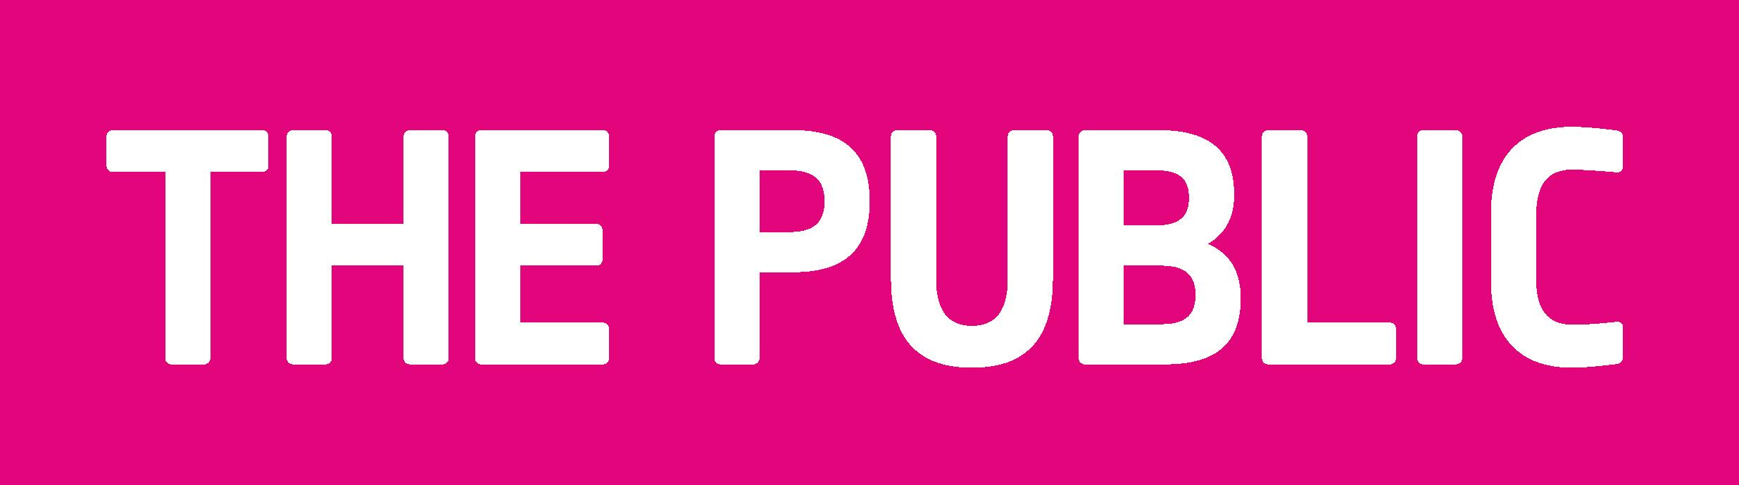

BRIEF – Bunting
Project Title: Bunting for the Public
Programme - July 2010 - 3 month period.

Artist details:

Name -
Details - How many pieces of work will be submitted ?

Statement – ideas and Inspiration.

Please send your submission to the following address:

Beth White
1 Upper Clifton Rd
Sutton Coldfield
Birmingham
B73 6BP

